CHAPTER 1
SheSync: Architecture and Exhaustive Rule-Level Verification of a Cross-Platform Self-Care Application for Menstrual and Endocrine Health
Sadhana Singh, Vyom Varshney*, Vishal Gupta, Shivangi Yadav, Vanshika Singh
Department of Computer Science and Engineering (Artificial Intelligence), ABES Institute of Technology, Ghaziabad, Uttar Pradesh, India, Email Id-vyomvarshney2005@gmail.com
Abstract: Menstrual-health apps increasingly give advice from hand-written scoring rules that are seldom tested systematically. This chapter presents SheSync, a React Native and Expo application for Android, iOS and the web, and an exhaustive verification of its analytics rules. One on-device routine turns a ten-item intake and daily logs into an archetype, a strain score, a workout-override state and graded anomaly flags for a clinician report. The production TypeScript store, with only network services stubbed, was executed on all 19,800 combinations of intake profile, sensitivity setting and daily-log value and checked against five properties. The score stayed within its bounds and never decreased with more pain or lower mood, but light flow scored below spotting in 19.3% of comparable pairs, two code paths labelled 6.9% of states differently, every state raised a severe or critical flag, and workouts were overridden in 83.0% of states; code inspection also found intake points that are never read. Five one-line refinements removed the first two defects, cut flags per state from 3.65 to 2.44 and override coverage to 65.9%, at under 1 ms per recomputation.
Keywords: Mobile health, Women’s health, React Native, Rule-based decision support, Software verification, Alert fatigue.
INTRODUCTION
Period trackers, used by tens of millions of people, are turning into self-care companions that interpret symptoms and recommend actions [1, 2]. When an app tells a user to rest instead of training, or to show a report to a doctor, the rule behind that advice becomes part of her care, yet such rules are usually hand-written and tested on a handful of examples. Women’s health apps also handle data poorly: 20 of the 23 most popular apps shared user data with third parties [3].
SheSync is the authors’ cross-platform app for users with irregular cycles, painful periods or premenstrual mood symptoms. Polycystic ovary syndrome is estimated to affect 6–10% of reproductive-age women [4] and is diagnosed partly from irregular cycles [5], primary dysmenorrhoea affects 45–95% of menstruating women [6], and premenstrual dysphoric disorder is a recognised diagnosis [7]. This chapter describes the app’s architecture, workflow and rules, presents an exhaustive method that executes the production rule code on every combination of its discrete inputs against five properties, and re-verifies a refined rule set with the same harness.
RELATED WORKS
Period apps often fail users with irregular cycles, explain little about their methods [1] and disagree on identical histories [2]. Cross-platform frameworks such as React Native serve Android, iOS and the web from one code base at some cost in device access and performance [8]. SheSync’s workout override draws on the allostatic-load view of accumulated stress [9] and on evidence that heavy training with low energy availability disrupts menstrual function [10]; its heavy-bleeding flag corresponds to the FIGO symptom of heavy menstrual bleeding [11]; and HRV metrics have established norms only when measured [12], which matters because SheSync estimates HRV-like values from self-report.
In clinical decision support, clinicians override 49–96% of drug safety alerts [13], repeated alerts are accepted less often as workload grows [14], and filtering and prioritising recommendations is a recognised grand challenge [15]. Model checking explores every reachable state of a system against formal properties [16, 17], property-based testing checks stated properties on generated inputs [18], and combinatorial testing observes that most failures involve a few interacting parameters, so covering all combinations of small discrete domains is effectively exhaustive [19]. App health rules have exactly such small discrete inputs.
PROPOSED WORK
3.1 System Architecture
SheSync is written in TypeScript with React Native 0.86 and Expo SDK 57 (Fig. 1). Expo Router maps 17 route files to screens, 22 shared components are styled with NativeWind, and state lives in one Zustand store; the code base has about 16,000 lines. Health logic is kept in pure functions, and every state-changing action ends in one routine, fineTuneAllAnalytics(), that recomputes all derived values in a single synchronous pass, which makes the analytics deterministic and exhaustively testable. Supabase provides e-mail authentication, with the session in AsyncStorage, and Postgres tables for profiles (names), cycles (start, end, length) and daily_logs (date, pain, mood, symptom locations, notes); writes are asynchronous and failures are caught, so the app works offline. The clinician report is rendered to PDF with expo-print, and no advertising or analytics SDKs are included.
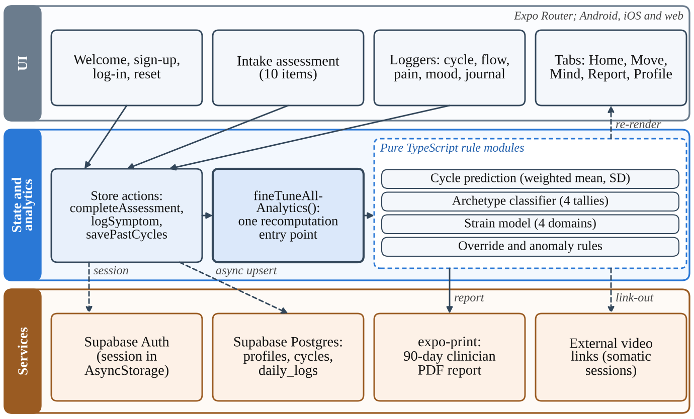
Figure 1. Three-layer architecture of SheSync. Every user action ends in one recomputation routine on the device; network calls are asynchronous.
3.2 User Workflow
At first launch the user signs up, answers the ten-item intake, enters up to four past cycles and a first pain, flow and mood log, and sees her archetype (Figs. 2 and 3). In daily use, a quick check-in logs mood, pain or flow and triggers fineTuneAllAnalytics(), which updates the home dashboard, the Move, Mind and Report tabs and the PDF export (Fig. 4).
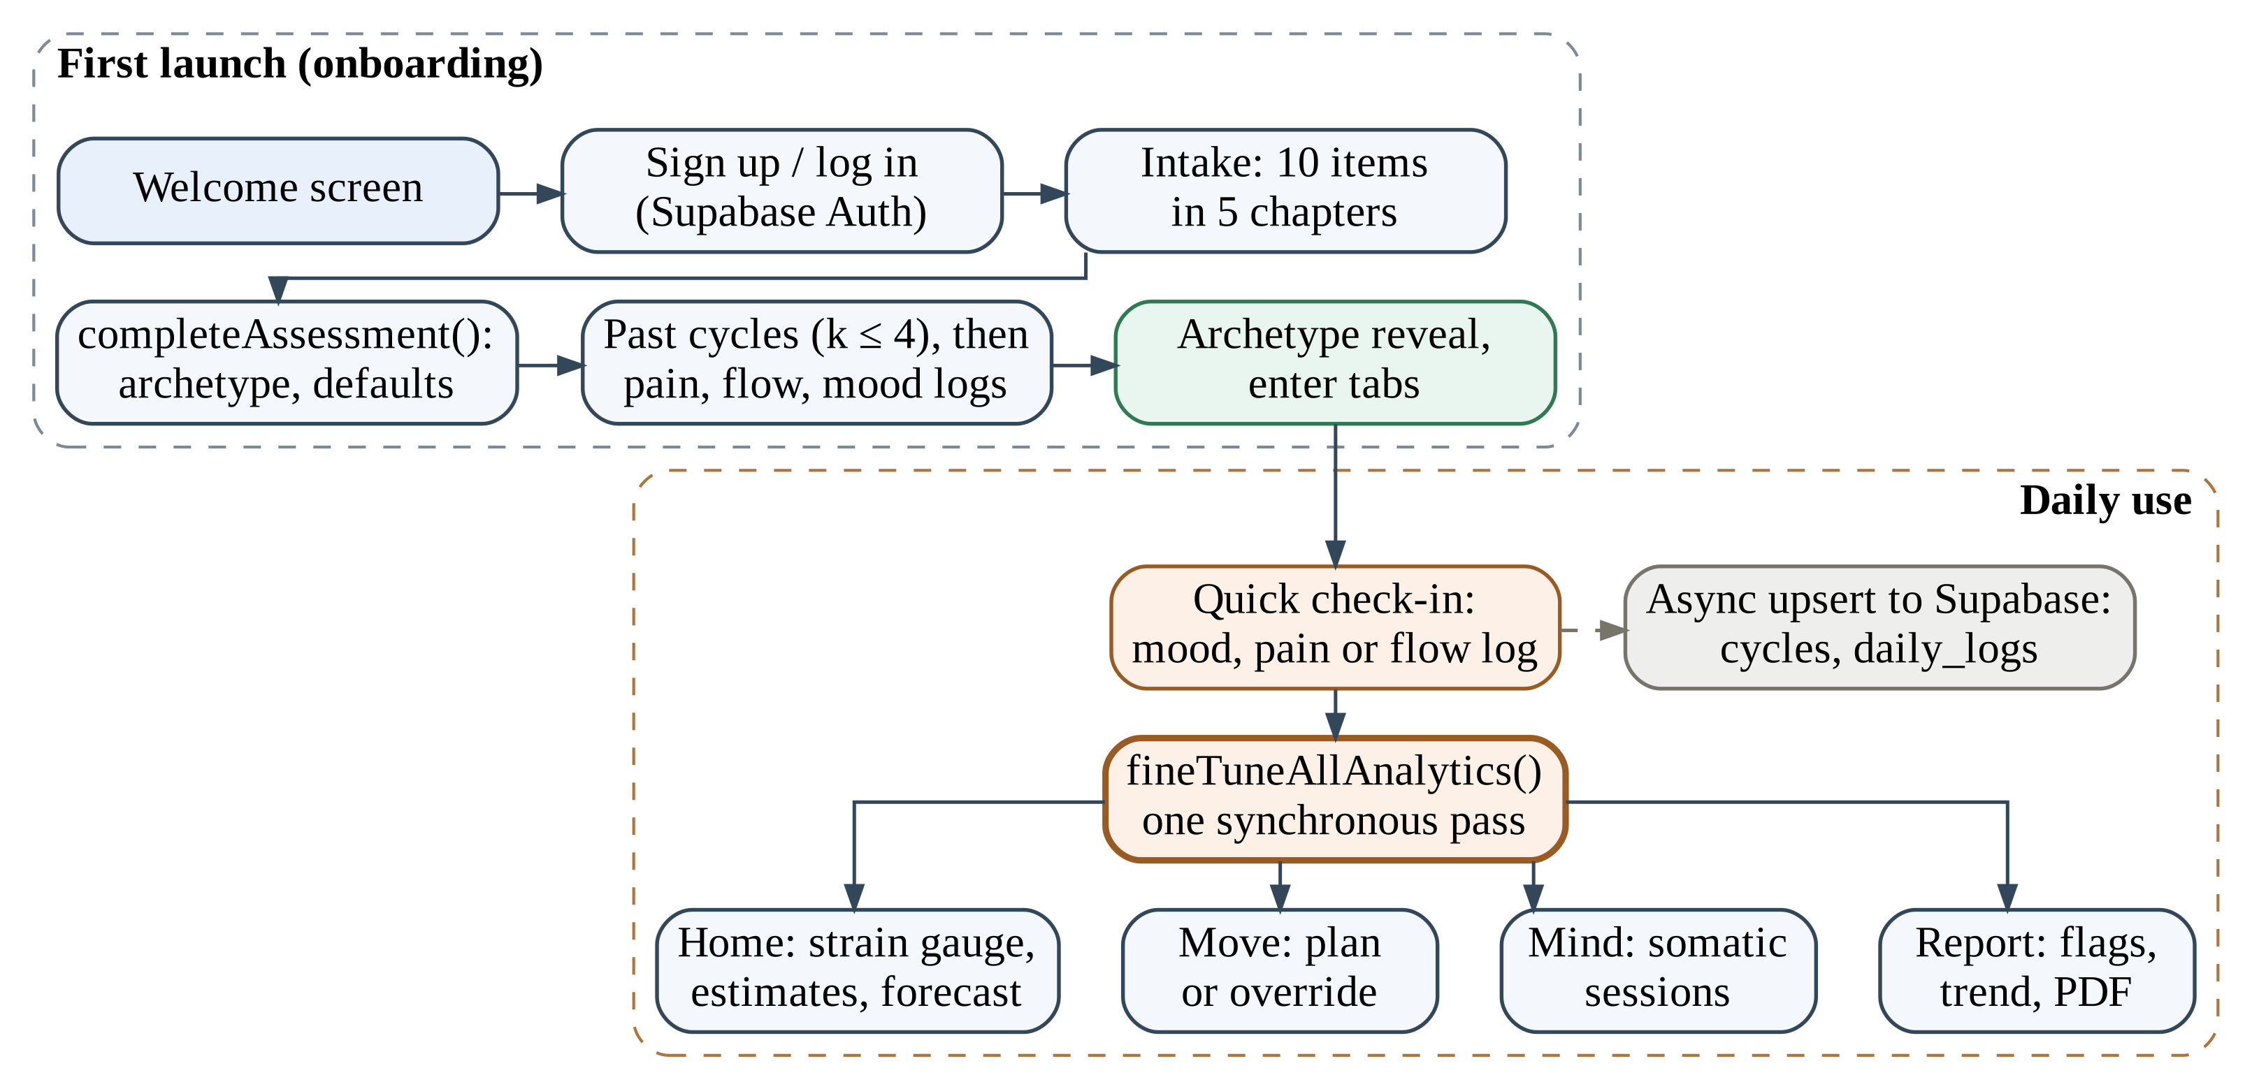
Figure 2. User workflow: onboarding on first launch and the daily check-in loop.
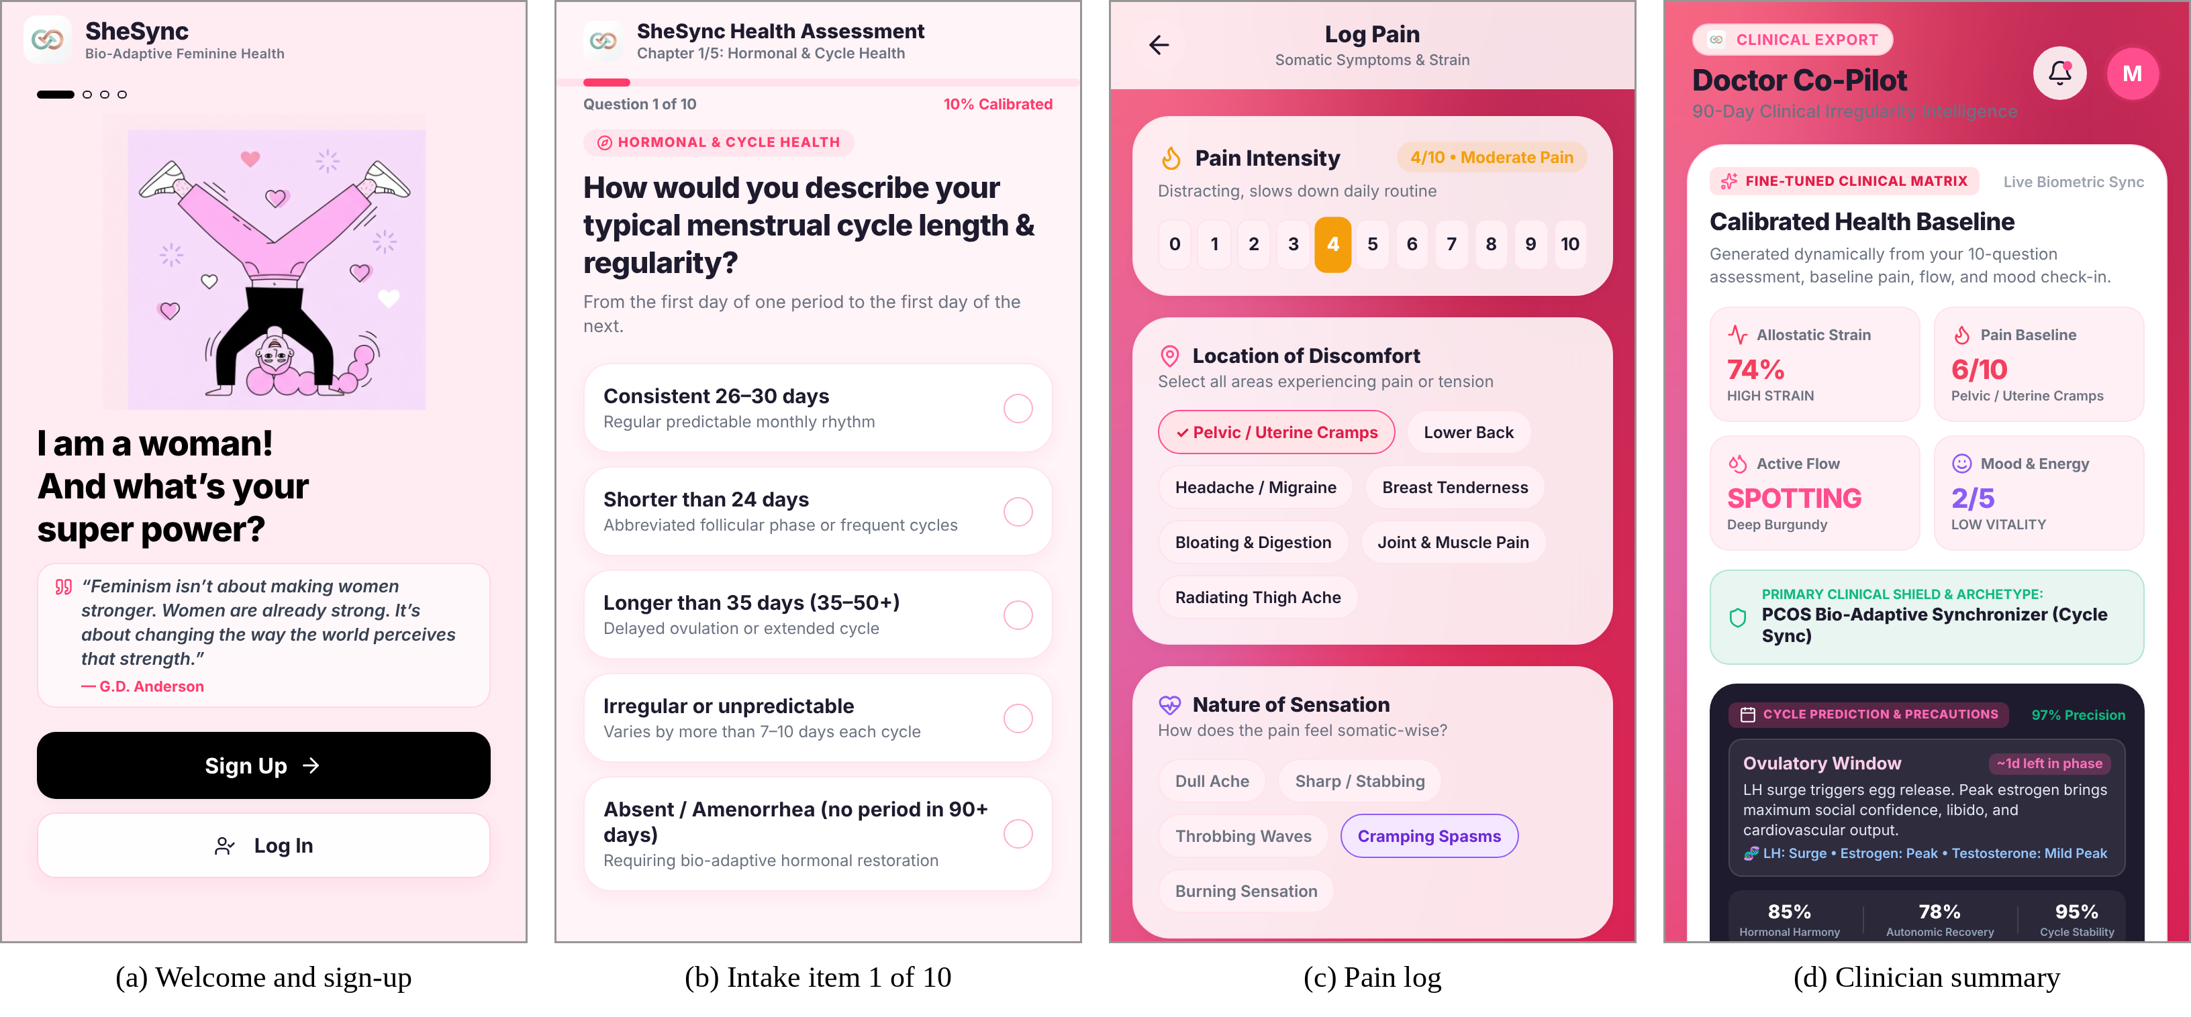
Figure 3. Onboarding screens (production web build): (a) welcome and sign-up, (b) first intake item, (c) pain log, (d) clinician summary.
3.3 Intake Assessment and Archetypes
The intake has ten single-choice items in five chapters, and selected options add points to tallies (Table 1). A first-match rule assigns an archetype: PCOS-oriented if P ≥ 4, the goal is cycle regulation or q1 reports long, irregular or absent cycles; PMDD-oriented if D ≥ 4, the goal is mood or q7 reports severe PMDD; restorative if C ≥ 4, S ≥ 4 or the goal is pelvic pain; and a cyclical optimiser otherwise. The first three default to “gentle” strain sensitivity, the last to “dynamic”.
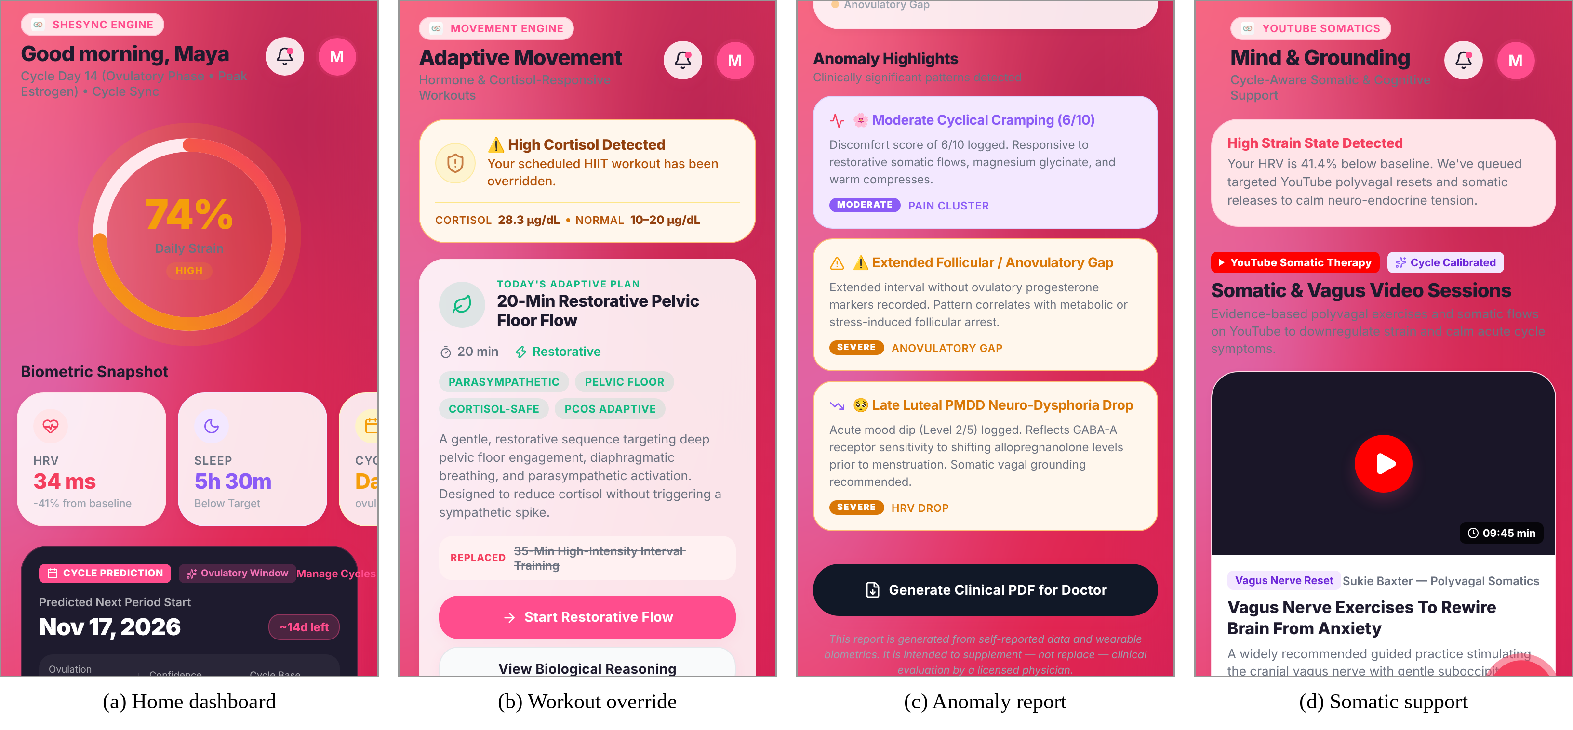
Figure 4. Daily-use screens: (a) home dashboard with strain gauge, (b) workout override, (c) anomaly highlights with PDF export, (d) somatic support.
Table 1. Intake items and the options that score (P PCOS, D PMDD, C cortisol, S strain, R recovery need).
Item | Scoring options
q1 Cycle length | > 35 d: P3; irregular: P4; absent: P5
q2 Flow and cramps | heavy: R3 S2; very heavy: R4 S4
q3 Energy pattern | surges and crashes: S2 D2; chronic fatigue: C4 R3
q4 Movement | restorative: R2; rebuilding stamina: S3 R3
q5 Sleep | luteal insomnia: D2 C2; chronic deficit: C4 R4
q6 Morning state | anxious waking: C4 S2; waking at 2–4 AM: C3 D2
q7 Premenstrual | moderate: D2; severe PMDD: D5 C2 S3
q8 Support style | none
q9 Metabolism | crashes or PCOS signs: P4; skipped meals: C3
q10 Goal | cycles/PCOS: P3; mood: D3; pelvic pain: S3 R3

3.4 Strain Score, Load State and Anomaly Rules
Each recomputation scores four domains from the intake and the latest log (Table 2) and combines them as
S = clamp_{[10, 96]}( round( s_{a} (D_{N} + D_{P} + D_{F} + D_{R}) ) ) (1)
with s_{a} = 1.08, 1.00 or 0.92 for gentle, balanced or dynamic sensitivity and levels low (< 36), moderate (36–59), high (60–79) and severe (≥ 80). The load state (Fig. 5) is “high” if S ≥ 65, pain ≥ 7 or mood ≤ 2, replacing a high-intensity session with a restorative one; “elevated” if S ≥ 40 or pain ≥ 5, which in the deployed version also overrides; otherwise “normal”. An HRV-like value of 74 − 0.46S ms, a sleep-deficit estimate and a cortisol label are derived from S and the intake; they are model estimates, not sensor readings.
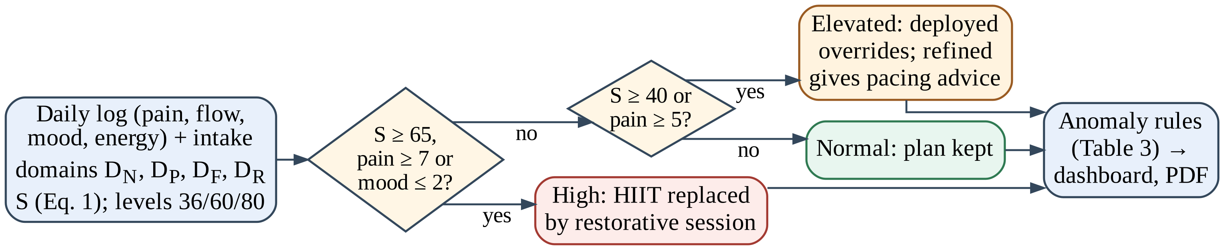
Figure 5. Decision flow from a daily log to the strain score, load state and anomaly flags.
Table 2. Strain domains: base points and increments in the deployed rules.
Domain | Points
D_{N} neuro-endocrine | 6; waking at 2–4 AM +10, anxious waking +6; severe PMDD +10, moderate +6; mood 1 +14, 2 +9, 4 −5, 5 −9
D_{P} pelvic | round(3.3 × pain); very heavy flow history +8, heavy +5
D_{F} flow | 4; severe +18, heavy +12, moderate +6, spotting +2, light and none 0
D_{R} recovery | 4; chronic sleep deficit +10, luteal insomnia +6; chronic fatigue +8, surges +5; energy low +7, high −6; irregular or absent cycles +6; tapping or breathwork preference +5

Four rule groups then raise graded flags for the dashboard and the PDF report (Table 3). Completing the intake also writes a condition list, to which pain ≥ 6, heavy flow, mood ≤ 2 and an irregular forecast later add Dysmenorrhea, Menorrhagia, PMDD and PCOS.
Table 3. Anomaly rule groups (first matching branch) and flag severity in the deployed rules.
Group | Condition → flag (severity)
Pain | pain ≥ 7 → severe pelvic pain (critical); 4–6 → moderate cramping (moderate); ≤ 3 → pelvic comfort (moderate)
Flow or cycle | heavy or severe flow → heavy bleeding (critical); PCOS listed or spotting → anovulatory gap (severe); else → phase synchronisation (moderate)
Mood or autonomic | mood ≤ 2 → luteal mood drop (severe); S ≥ 65 or HRV ≤ −20% → HRV suppression (moderate); else → vagal tone (moderate)
Sleep | sleep deficit → sleep debt (moderate)

3.5 Verification Method
The production store was bundled with esbuild into a Node.js module, with only the Supabase and PDF services stubbed. A harness resets the store, completes the intake with one of five profiles (none, PCOS-type, PMDD-type, high-stress, low-risk), sets the sensitivity, injects one daily log and calls fineTuneAllAnalytics(). With five profiles, three sensitivities, 11 pain, six flow, five mood and four energy values, the input space
|X| = 5 × 3 × 11 × 6 × 5 × 4 = 19,800 (2)
is enumerated completely against five properties. P1: S ∈ [10, 96]. P2: S(x) ≤ S(x′) for every adjacent pair in which x′ has one step more pain, heavier flow (none < spotting < light < moderate < heavy < severe) or lower mood. P3: every code path gives the same level label. P4: a low-risk user on a mild day (pain ≤ 3, at most light flow, mood ≥ 3) receives no severe or critical flag. P5: overrides are selective. As the enumeration is complete, P1–P3 are established exactly rather than sampled; P4 and P5 are measured.
RESULT AND DISCUSSION
4.1 Bounds, Monotonicity and Label Consistency
S ranged from 10 to 96 (median 50, interquartile range 35–66), so P1 held, and it never fell when pain rose (18,000 pairs) or mood fell (15,840 pairs). The flow domain, however, has no branch for “light”, a category the flow logger offers, so light flow scores 0 points and spotting 2: S decreased in 3,179 of 16,500 flow pairs (19.3%), all spotting → light (Fig. 6a). P3 also failed: the recomputation routine labels levels at 36/60/80 but a separate setter uses 38/62/82, so 1,375 states (6.9%) are labelled differently depending on which path last wrote the score.
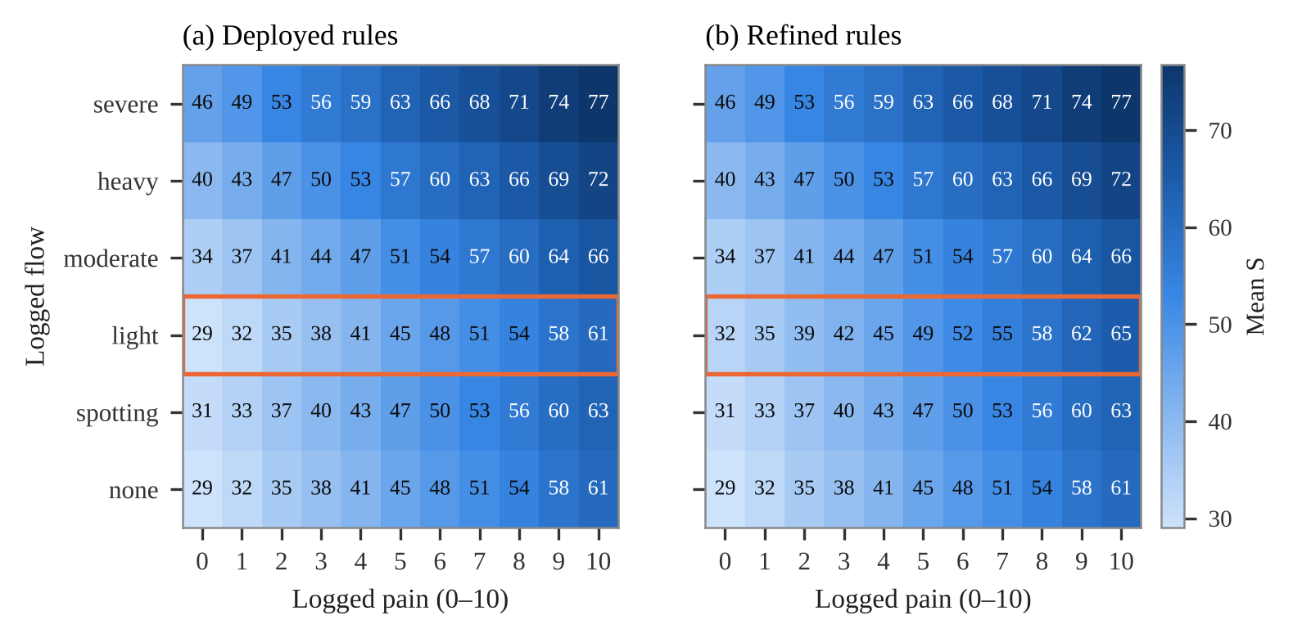
Figure 6. Mean strain score by logged pain and flow over all profiles, sensitivities, moods and energy levels: (a) deployed rules, with light flow scoring below spotting; (b) refined rules.
4.2 Flag Specificity and Override Coverage
Flags were not specific (P4): every state produced at least one severe or critical flag, 3.65 flags per state on average. Completing the intake initialises every user’s condition list with PCOS, which triggers the severe anovulatory-gap flag whenever flow is not heavy, and the “normal” branches of three rule groups still emit moderate cards. Since frequent alerts are quickly ignored [13, 14], this is the most consequential defect. Overrides covered 83.0% of states (Fig. 7), triggered first by S ≥ 65 (5,368 states), pain ≥ 7 (4,114), mood ≤ 2 (3,532), S ≥ 40 (2,506) or pain ≥ 5 (909). Code inspection added that recovery-need (R) points appear in seven intake options but are never summed, and that a preference for tapping or breathwork raises the strain score although it is not a symptom.
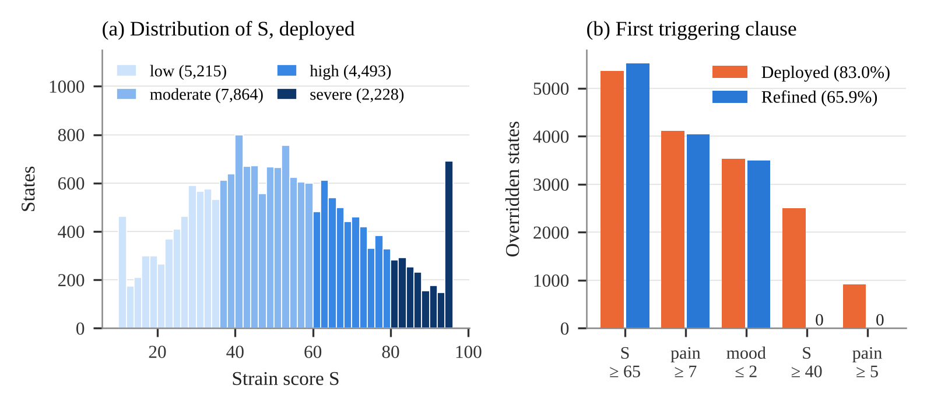
Figure 7. (a) Distribution of S over the 19,800 states by level, deployed rules. (b) Overridden states by the first clause that triggered the override.
4.3 Refined Rule Set
Five one-line changes were applied to a copy of the store and verified with the same harness: light flow scores 4 points; the intake no longer seeds PCOS, so conditions come from logged evidence; “normal” outcomes become status text; “elevated” load gives pacing advice without overriding; and one threshold set labels levels on every path. Flow violations and label mismatches disappeared, and flags per state, flags on mild low-risk days and override coverage all fell (Table 4). The remaining severe flags on mild days come from the spotting rule, which still reads spotting as an anovulatory gap.
Table 4. Verification of the deployed and refined rules over the 19,800 enumerated states.
Property | Deployed | Refined
P1 S within [10, 96] | holds | holds
P2 pain, 18,000 pairs | 0 violations | 0 violations
P2 mood, 15,840 pairs | 0 violations | 0 violations
P2 flow, 16,500 pairs | 3,179 (19.3%) | 0 violations
P3 states labelled differently | 1,375 (6.9%) | 0
P4 mean flags per state | 3.65 | 2.44
P4 states with a severe or critical flag | 100% | 84.7%
P4 low-risk mild day: mean flags | 3.25 | 0.58
P5 states with workout override | 83.0% | 65.9%

4.4 Profiles and Personas
Mean S was 39.0 for the no-assessment, low-risk and PCOS-type profiles, 62.8 for high-stress and 74.0 for PMDD-type; the PCOS-type answers do not enter the strain domains at all. In the persona runs (Table 5), a low-risk user logging pain 2, light flow and mood 4 received three cards, one severe, before refinement and none after, while a user logging pain 9 was rightly overridden with a score of only 57, so the app should show the triggering clause, not only the score.
Table 5. Persona scenarios (deployed → refined).
Persona | Pain / flow / mood | S | Override | Flags
P1 low-risk, dynamic | 2 / light / 4 | 10 → 13 | no | 3 → 0
P2 PCOS-type | 4 / spotting / 3 | 31 | no | 3 → 2
P3 PMDD-type | 5 / none / 1 | 95 | yes | 4 → 3
P4 high-stress | 7 / heavy / 2 | 96 | yes | 4 → 4
P5 severe dysmenorrhoea | 9 / severe / 3 | 57 | yes | 4 → 3

4.5 Runtime Cost and Limitations
One recomputation took 0.46 ms on average (95th percentile 0.64 ms) and a cycle prediction 0.44 ms (Node.js v22, one 2.1 GHz Xeon core); the full enumeration ran in 47 s and can run in continuous integration. The verification covers rule logic, not clinical validity, and the thresholds remain expert-chosen. HRV, sleep and cortisol estimates should be labelled as such or replaced by wearable data [12]; flow, energy and intake answers are not yet synchronised; and row-level security, a privacy notice and explicit consent are needed before release [3]. SheSync does not diagnose; its flags are meant to start a conversation with a clinician.
CONCLUSION
Keeping all health reasoning in one deterministic on-device routine made complete verification of SheSync practical. Running the production rules on all 19,800 input combinations exposed a non-monotonic flow score, inconsistent level thresholds, flags that fire for everyone and an override that covers most states, all missed by example-based testing. Five small changes fixed or reduced each at no runtime cost. A consented pilot with users and clinicians is the next step.
Conflict of Interest
The authors declare no conflict of interest.
REFERENCES
- Worsfold, L., Marriott, L., Johnson, S., & Harper, J.C. (2021). Period tracker applications: What menstrual cycle information are they giving women? Women’s Health, 17, 17455065211049905.
- Epstein, D.A., Lee, N.B., Kang, J.H., Agapie, E., Schroeder, J., Pina, L.R., Fogarty, J., Kientz, J.A., & Munson, S.A. (2017). Examining menstrual tracking to inform the design of personal informatics tools. Proceedings of the 2017 CHI Conference on Human Factors in Computing Systems, 6876–6888.
- Alfawzan, N., Christen, M., Spitale, G., & Biller-Andorno, N. (2022). Privacy, data sharing, and data security policies of women’s mHealth apps: Scoping review and content analysis. JMIR mHealth and uHealth, 10(5), e33735.
- Bozdag, G., Mumusoglu, S., Zengin, D., Karabulut, E., & Yildiz, B.O. (2016). The prevalence and phenotypic features of polycystic ovary syndrome: A systematic review and meta-analysis. Human Reproduction, 31(12), 2841–2855.
- Teede, H.J., Tay, C.T., Laven, J.J.E., Dokras, A., Moran, L.J., Piltonen, T.T., et al. (2023). Recommendations from the 2023 international evidence-based guideline for the assessment and management of polycystic ovary syndrome. Journal of Clinical Endocrinology & Metabolism, 108(10), 2447–2469.
- Iacovides, S., Avidon, I., & Baker, F.C. (2015). What we know about primary dysmenorrhea today: A critical review. Human Reproduction Update, 21(6), 762–778.
- Epperson, C.N., Steiner, M., Hartlage, S.A., Eriksson, E., Schmidt, P.J., Jones, I., & Yonkers, K.A. (2012). Premenstrual dysphoric disorder: Evidence for a new category for DSM-5. American Journal of Psychiatry, 169(5), 465–475.
- Biørn-Hansen, A., Grønli, T.-M., & Ghinea, G. (2018). A survey and taxonomy of core concepts and research challenges in cross-platform mobile development. ACM Computing Surveys, 51(5), Article 108.
- McEwen, B.S. (1998). Protective and damaging effects of stress mediators. New England Journal of Medicine, 338(3), 171–179.
- Mountjoy, M., Sundgot-Borgen, J.K., Burke, L.M., et al. (2018). IOC consensus statement on relative energy deficiency in sport (RED-S): 2018 update. British Journal of Sports Medicine, 52(11), 687–697.
- Munro, M.G., Critchley, H.O.D., Fraser, I.S., & FIGO Menstrual Disorders Committee. (2018). The two FIGO systems for normal and abnormal uterine bleeding symptoms and classification of causes of abnormal uterine bleeding in the reproductive years: 2018 revisions. International Journal of Gynecology & Obstetrics, 143(3), 393–408.
- Shaffer, F., & Ginsberg, J.P. (2017). An overview of heart rate variability metrics and norms. Frontiers in Public Health, 5, 258.
- van der Sijs, H., Aarts, J., Vulto, A., & Berg, M. (2006). Overriding of drug safety alerts in computerized physician order entry. Journal of the American Medical Informatics Association, 13(2), 138–147.
- Ancker, J.S., Edwards, A., Nosal, S., Hauser, D., Mauer, E., & Kaushal, R. (2017). Effects of workload, work complexity, and repeated alerts on alert fatigue in a clinical decision support system. BMC Medical Informatics and Decision Making, 17, 36.
- Sittig, D.F., Wright, A., Osheroff, J.A., Middleton, B., Teich, J.M., Ash, J.S., Campbell, E., & Bates, D.W. (2008). Grand challenges in clinical decision support. Journal of Biomedical Informatics, 41(2), 387–392.
- Clarke, E.M., & Wing, J.M. (1996). Formal methods: State of the art and future directions. ACM Computing Surveys, 28(4), 626–643.
- Baier, C., & Katoen, J.-P. (2008). Principles of model checking. MIT Press.
- Claessen, K., & Hughes, J. (2000). QuickCheck: A lightweight tool for random testing of Haskell programs. Proceedings of the Fifth ACM SIGPLAN International Conference on Functional Programming (ICFP ’00), 268–279.
- Kuhn, D.R., Wallace, D.R., & Gallo, A.M. (2004). Software fault interactions and implications for software testing. IEEE Transactions on Software Engineering, 30(6), 418–421.

*Address correspondence to vyomvarshney2005@gmail.com: Vyom Varshney, Department of Computer Science and Engineering (Artificial Intelligence), ABES Institute of Technology, Ghaziabad, Uttar Pradesh, India; Email Id-vyomvarshney2005@gmail.com

